LAB REPORT NO 11
Power Management



Spring 2026
CSE-420L Embedded Systems LAB

Submitted By: Naveed Ahmad
Registration No: 22PWCSE2165
Section: B

“On my honor, as student of University of Engineering and Technology, I have neither given nor received unauthorized assistance on this academic work”

Submitted to:
Engr. Muhammad Shahzad
June 25, 2026

Department of Computer Systems Engineering
University of Engineering and Technology Peshawar
Title: Power Management

Objective:
The objective of this lab is to study different power management techniques in embedded systems using the ATmega328P microcontroller. The lab focuses on reducing power consumption by using sleep modes, timer interrupts, and disabling unused peripherals.

Class lecture:
MC’s Consumes power mainly in
- CPU operation
- Clock system
- GPIO switching
- Communication peripherals
- ADC/DAC Modules
- Timers

Power Consumption depends upon
- Clock frequency
- Supply voltage
- Number of enable peripherals
- CPU

Mode:
- Active mode CPU and Peripheral fully active
- Idle mode CPU stops but peripherals running.
- Sleep Mode Most internal modes disabled
- Power Down mode Almost everything turned off.
- Standby mode lowest power mode with quick wakeup.

Sleep Mode:
- CPU clock is stopped.
- Program execution power.
- Power consumption is very low.
- External interrupt can wakeup MCV.

Register Used (ATmega328p):
- SMCR Sleep mode control Register
Bit Name
SE Sleep enable
SM Sleep mode select

- MCUCR MCU control register.
-Used for interrupt trigging configuration.
- EIMSK External Interrupt mask Register
-Used to enable external interrupts.
- EIFR External interrupt flag Register.
-Stores interrupt flags.

Power Reduction Registers --PRR
BIT Peripheral
PRADC ADC

Apparatus:
- Arduino Uno / ATmega328P Microcontroller
- Push Button
- Breadboard
- LED
- Resistors
- Jumper Wires
- USB Cable
- Computer with Arduino IDE

Theory:
Power management is an important part of embedded systems because microcontrollers consume power during CPU processing, clock operation, GPIO switching, timers, communication modules, and ADC/DAC operations. Reducing power consumption increases battery life and improves system efficiency.
The ATmega328P provides different power-saving modes such as:
- Active Mode: CPU and peripherals remain fully active.
- Idle Mode: CPU stops working but peripherals continue running.
- Sleep Mode: Most internal modules are disabled to save power.
- Power Down Mode: Almost all internal circuits are turned off.
- Standby Mode: Lowest power mode with fast wake-up capability.
Important registers used in power management are:
- SMCR: Controls sleep modes.
- MCUCR: Configures interrupts.
- EIMSK: Enables external interrupts.
- EIFR: Stores interrupt flags.
- PRR: Disables unused peripherals to save power.

Task01:
Basic sleep mode
Put MC into sleep mode and wake it up using external interrupt.
(Sleep mode power down)

Procedure:
- Build the circuit on breadboard.
- Upload the code to Arduino Uno.
- Observe that the MCU enters sleep mode.
- Press the push button to generate interrupt.
- MCU wakes up and LED operation resumes.
Circuit Diagram and output:
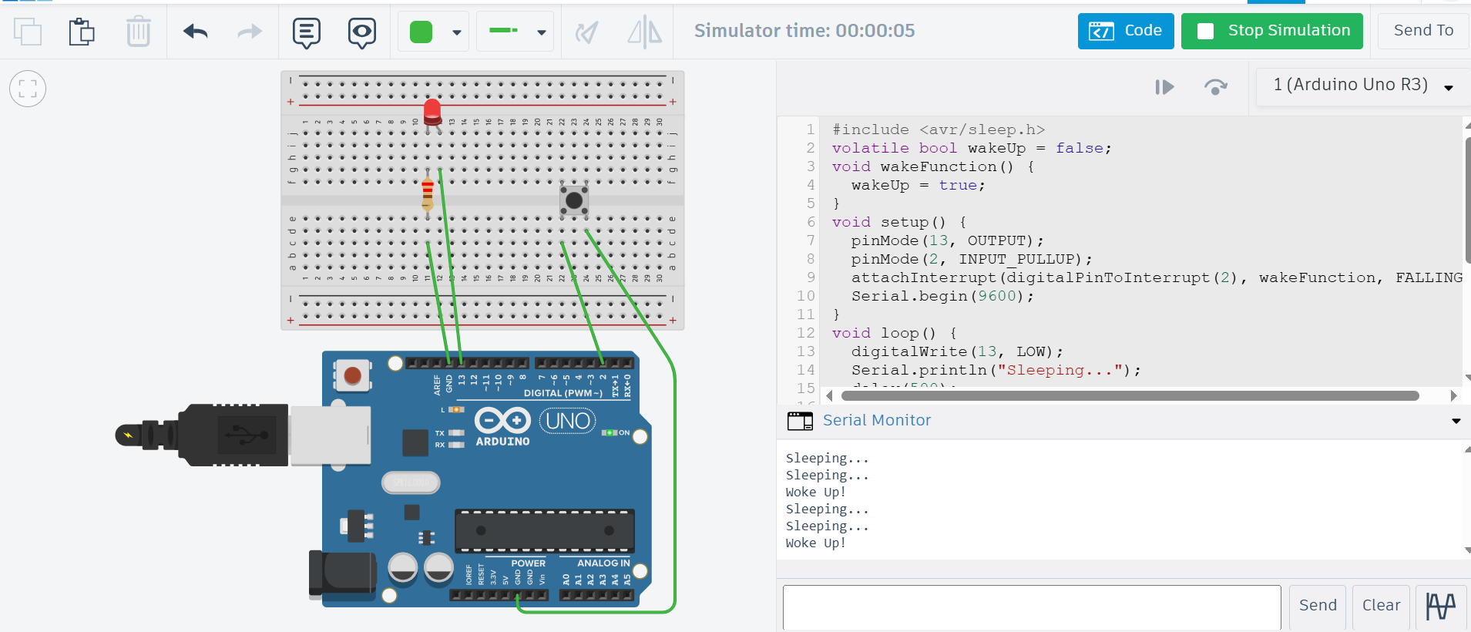

Connections:
- LED connected to digital pin 13.
- Push button connected to interrupt pin.
- Ground and VCC connected properly.
Code:
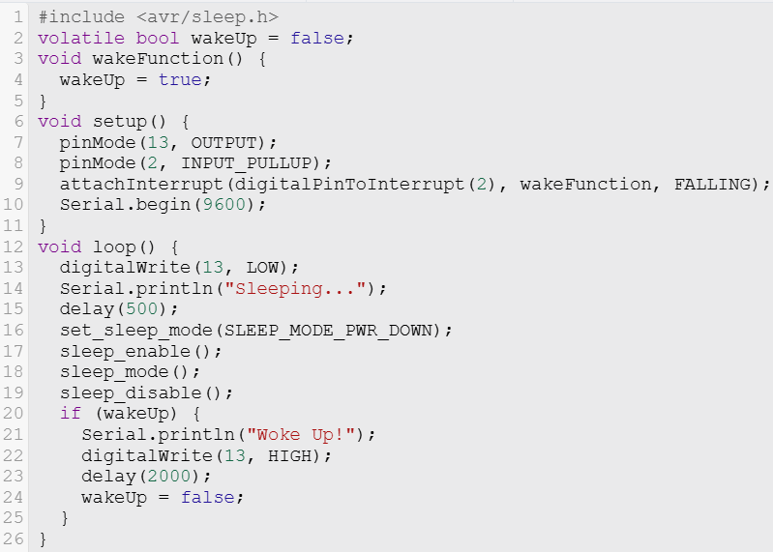

Algorithm:
- Initialize the microcontroller.
- Configure sleep mode as power-down mode.
- Put the MCU into sleep mode.
- Wait for external interrupt from push button.
- Wake up the MCU and continue execution.

Result:
The microcontroller successfully entered sleep mode and woke up through an external interrupt, reducing power consumption during inactive time.

Task 02:
Timer Based wakeup
Wake-up the MCU periodically using timer interrupts.
(Sleep mode Idle)

Procedure:
- Connect the circuit and upload the code.
- Configure Timer1 interrupt in the program.
- Observe the MCU entering idle sleep mode.
- Timer interrupt wakes up MCU repeatedly.
- LED blinks periodically after each wake-up.
Circuit Diagram and output:
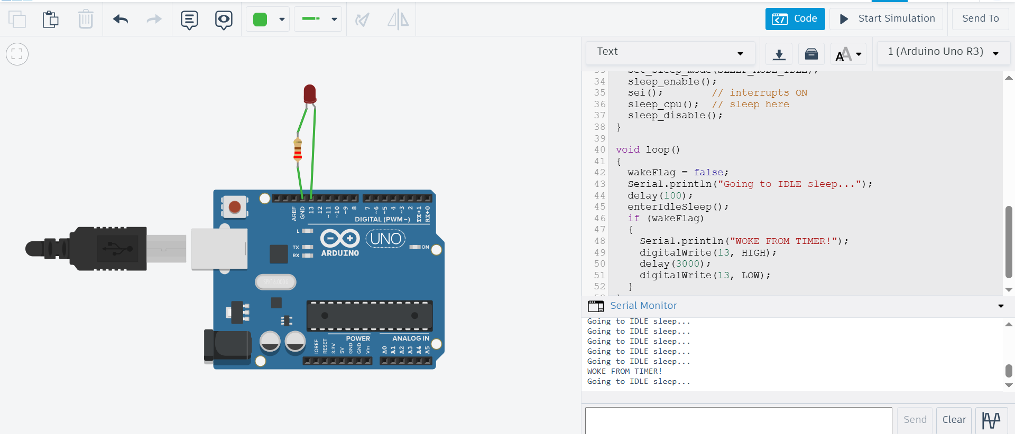

Connections:
- LED connected to pin 13.
- Timer interrupt configured internally.
- Power connections provided to Arduino board.
Code:
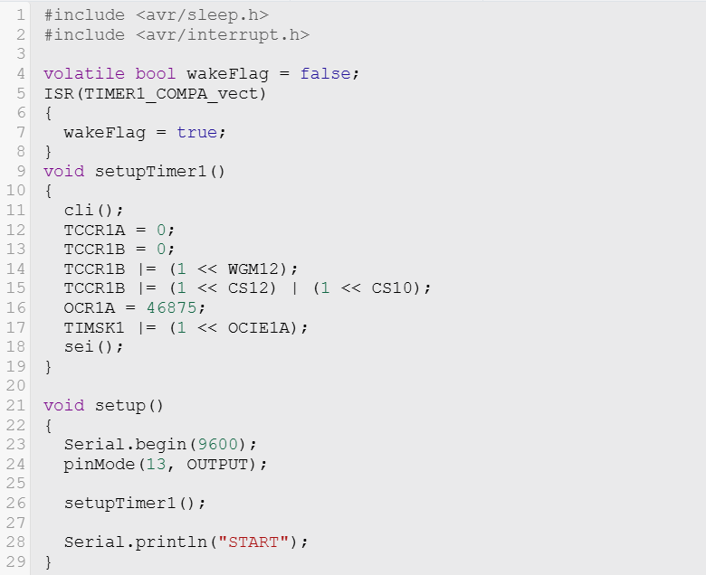
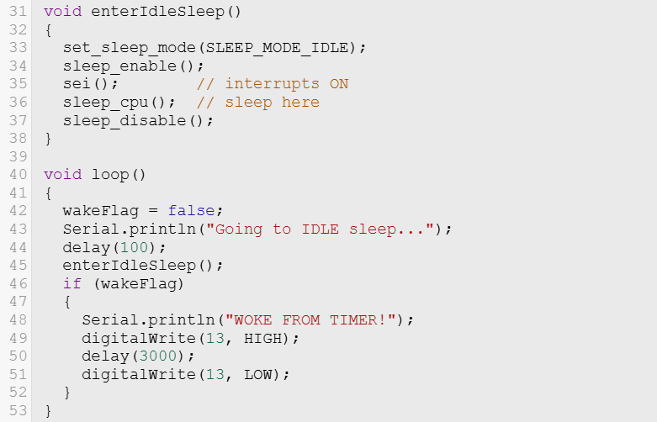

Algorithm:
- Configure Timer1 interrupt.
- Set sleep mode to idle mode.
- Put MCU into sleep mode.
- Timer interrupt occurs after a fixed interval.
- MCU wakes up periodically and performs tasks.

Result:
The timer interrupt successfully woke the MCU at regular intervals while the system remained in low-power idle mode.

Task 03:
Peripheral power saving
Reduce the power consumption by disabling unused peripherals.
Unused peripherals still use power
Example:
ADC ADC disable
SPI
I2C ADCSRA &=~(1<<ADEN); // Disable
Timers
UART ADCSRA |=(1<<ADEN); // Enable

Procedure:
- Upload the program to Arduino board.
- Disable unused peripherals in code.
- Observe reduced activity of modules.
- Re-enable peripherals when needed.
- Compare power-saving behavior.

Circuit Diagram and output:
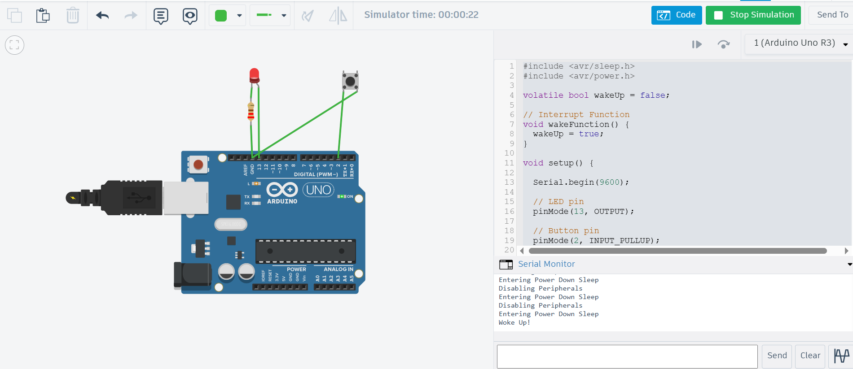

Connections:
- Arduino Uno connected normally.
- LED connected for output indication.

Code:

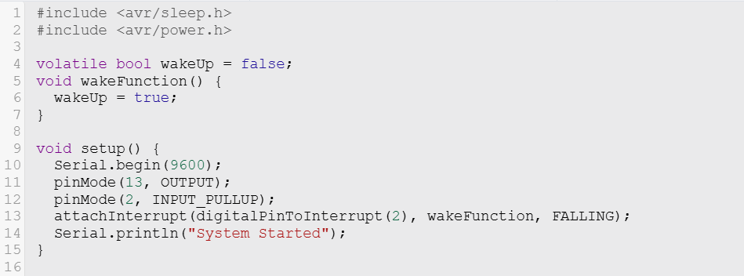

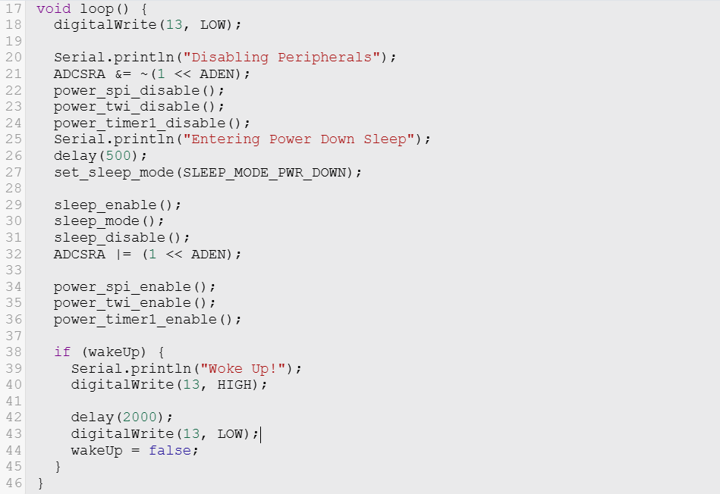

Algorithm:
- Identify unused peripherals.
- Disable unused modules such as ADC, SPI, I2C, UART, and Timers.
- Run the system with reduced peripherals.
- Enable peripherals again when required.

Result:
Power consumption was reduced successfully by disabling unused peripherals, improving the efficiency of the embedded system.

Conclusion:
In this lab, different power management techniques of the ATmega328P were studied successfully. Sleep modes, timer interrupts, and peripheral disabling methods helped reduce power consumption effectively. The lab showed how embedded systems can save energy and improve battery performance by using proper power management techniques.

________________________________END_____________________________

